Q1

#include <stdio.h>

#include <string.h>

#include <mpi.h>

int main(int argc, char *argv[])

{

int rank, size, n;

MPI_Status status;

MPI_Init(&argc, &argv);

MPI_Comm_size(MPI_COMM_WORLD, &size);

MPI_Comm_rank(MPI_COMM_WORLD, &rank);

if (rank == 0)

{

char a[25];

fprintf(stdout, "Enter the Word : \n");

fflush(stdout);

scanf("%s", a);

n = strlen(a);

MPI_Ssend(&n, 1, MPI_INT, 1, 0, MPI_COMM_WORLD);

printf("Sent\n");

MPI_Ssend(a, n + 1, MPI_CHAR, 1, 1, MPI_COMM_WORLD);

fprintf(stdout, "Process %d sent: %s\n", rank, a);

fflush(stdout);

MPI_Recv(a, n + 1, MPI_CHAR, 1, 2, MPI_COMM_WORLD, &status);

fprintf(stdout, "Process %d recieved: %s\n", rank, a);

fflush(stdout);

}

else if (rank == 1)

{

char b[25];

MPI_Recv(&n, 1, MPI_INT, 0, 0, MPI_COMM_WORLD, &status);

printf("Got\n");

MPI_Recv(b, n + 1, MPI_CHAR, 0, 1, MPI_COMM_WORLD, &status);

fprintf(stdout, "Process %d recieved: %s\n", rank, b);

fflush(stdout);

for (int i = 0; i < n; i++)

{

if (b[i] >= 'a' && b[i] <= 'z')

{

b[i] = b[i] - 32;

}

else

{

b[i] = b[i] + 32;

}

}

MPI_Ssend(b, n + 1, MPI_CHAR, 0, 2, MPI_COMM_WORLD);

fprintf(stdout, "Process %d sent: %s\n", rank, b);

fflush(stdout);

}

MPI_Finalize();

return 0;

}

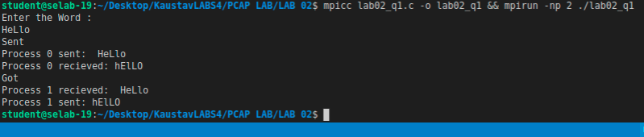

Q2

#include "mpi.h"

#include <stdio.h>

int main(int argc, char *argv[])

{

int a, b, c;

int rank, size;

MPI_Status status;

MPI_Init(&argc, &argv);

MPI_Comm_rank(MPI_COMM_WORLD, &rank);

MPI_Comm_size(MPI_COMM_WORLD, &size);

if (rank == 0)

{

printf("Enter a value in the master process (rank %d) ", rank);

scanf(" %d", &a);

for (int i = 1; i < size; i++)

MPI_Send(&a, 1, MPI_INT, i, 1, MPI_COMM_WORLD);

}

else

{

MPI_Recv(&b, 1, MPI_INT, 0, 1, MPI_COMM_WORLD, &status);

fprintf(stdout, "Rank %d process received: %d \n", rank, b);

}

MPI_Finalize();

return 0;

}

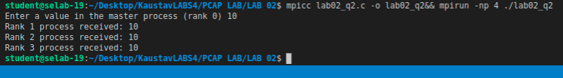

Q3

#include "mpi.h"

#include <stdio.h>

#include <stdlib.h>

int main(int argc, char *argv[])

{

int x;

int rank, size;

MPI_Status status;

MPI_Init(&argc, &argv);

MPI_Comm_rank(MPI_COMM_WORLD, &rank);

MPI_Comm_size(MPI_COMM_WORLD, &size);

if (rank == 0)

{

int *arr = (int *)calloc(size, sizeof(int));

printf(" Enter %d number of values in the aray ", size - 1);

for (int i = 1; i < size; i++)

scanf(" %d", &arr[i]);

for (int i = 1; i < size; i++)

MPI_Send(&arr[i], 1, MPI_INT, i, i, MPI_COMM_WORLD);

}

else

{

MPI_Recv(&x, 1, MPI_INT, 0, rank, MPI_COMM_WORLD, &status);

if (rank % 2 == 0)

fprintf(stdout, "Even Rank %d process received: %d. After Squaring even ranked process : %d \n", rank, x, x * x);

else

fprintf(stdout, "Odd Rank %d process received: %d. After Cubing odd ranked process : %d \n", rank, x, x * x * x);

fflush(stdout);

}

MPI_Finalize();

return 0;

}

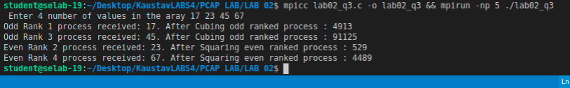

Q4

#include "mpi.h"

#include <stdio.h>

int main(int argc, char *argv[])

{

int a, b, c;

int rank, size;

MPI_Status status;

MPI_Init(&argc, &argv);

MPI_Comm_rank(MPI_COMM_WORLD, &rank);

MPI_Comm_size(MPI_COMM_WORLD, &size);

if (rank == 0)

{

printf("Enter a value in the master process (rank %d) ", rank);

scanf(" %d", &a);

MPI_Send(&a, 1, MPI_INT, 1, size, MPI_COMM_WORLD);

MPI_Recv(&a, 1, MPI_INT, size - 1, size, MPI_COMM_WORLD, &status);

a = a + 1;

fprintf(stdout, "Rank %d process received: %d from process %d \n", rank, a, size - 1);

fflush(stdout);

}

else if (rank != size - 1)

{

MPI_Recv(&b, 1, MPI_INT, rank - 1, size, MPI_COMM_WORLD, &status);

fprintf(stdout, "Rank %d process received : %d from process %d \n", rank, b, rank - 1);

fflush(stdout);

b = b + 1;

MPI_Send(&b, 1, MPI_INT, rank + 1, size, MPI_COMM_WORLD);

}

else

{

MPI_Recv(&c, 1, MPI_INT, size - 2, size, MPI_COMM_WORLD, &status);

fprintf(stdout, "Rank %d process received: %d from process %d \n", rank, c, rank - 1);

MPI_Send(&c, 1, MPI_INT, 0, size, MPI_COMM_WORLD);

fflush(stdout);

}

MPI_Finalize();

return 0;

}

